# What Does It Mean To Be A People of Wisdom?

When the topic of wisdom comes up, so do the usual images. Walls and walls filled with dusty old books. Elders with the wisdom of many years carved into the wrinkles on their faces. Diplomas framed and filling one’s office wall. Endless letters placed in front and behind your name (Dr., PhD., LCSW, JD, Rev., etc.)

The message: wisdom is about accumulation. If you want to be wise, you need to pile it on. More knowledge. More experience. More books to read. More gurus to follow. More degrees to get.

But then words like these sneak into the conversation:

*Knowledge is a process of piling up facts; wisdom lies in their simplification.*

*- Martin H. Fischer*

*There is no need to “acquire” the knowledge of God. There is only the dropping of the illusion and forgetfulness. - Omid Safi*

*Besides the noble art of getting things done, there is the noble art of leaving things undone. The wisdom of life consists in the elimination of non-essentials.*

*- Lin Yutang*

It’s a reminder that the math of wisdom is often the opposite of what we think. It’s more a game of subtraction than addition. Often, accumulation of knowledge doesn’t get us closer to wisdom; it’s just in the way. There’s a sorting, simplifying and stripping away that needs to occur. It’s about unknowing as much as knowing.

Just think about how deeply we get tangled up in those cultural messages about money and success. Or the way degrees, IQs tests and SAT numbers get mixed up with status rather than the pursuit of truth. Or the way political parties, religions and even science claim to have *all* the answers. Maybe this is why the Sufi poet Hafiz wrote:

*The Beloved sometimes wants*

*To do us a great favor:*

*Hold us upside down*

*And shake all the nonsense out.*

And with all the nonsense shaken out and stripped away, maybe what we notice most is not so much the pearls of wisdom themselves, but the sources of wisdom we’ve forgotten.

When reason and logic hog the spotlight, the wisdom of the body rarely enters the room. When week-long retreats with the newest guru define the path to wisdom, we stop asking what our failures and mistakes are trying to teach us. When “experts” sit in the center, the wisdom of those on the margins is lost.

So many untapped sources. So much wisdom waiting to be known.

Makes one think that maybe the wisest question of all this month is: “Where have I not looked before?”

# Our Spiritual Exercise

## The Best Advice You've Received

Wisdom is a gift. We pass it on to each other like a precious jewel. None of us want others to make the same mistakes we did, so we generously share our advice.

In other words, wisdom connects us. It’s not just something we collect to uplift ourselves. It’s something we pass on so we can all make it through together. Or to put it another way, wisdom and kindness are more closely linked than we acknowledge.

To honor this, we’re invited this month to remember the wisdom we’ve received.

To help, we’ve assembled some awesome videos and articles to jog your memory.

**Here are your instructions:**

1. Make time to meditate and reflect on the videos and articles below.
2. Let them take you back in time to the best advice you got from others.
3. Then, out of all those memories (and pieces of advice) pick the one you think is most relevant to you currently. Pick the one your life right now needs you to remember.
4. Come to your group ready to share your journey.

**Add Ons:**

* Make this exercise richer by asking someone close to you about the best advice they received. Maybe even interview a few folks. It’s not only a great way to help them remember the gifts of wisdom they’ve received, but it’s also a sneaky way for you to get some more great advice passed on to you! :)
* You might also listen to the videos for new wisdom you need to hear. As you watch and listen, ask yourself, “Is any of this advice, the wisdom I need right now?”

**Must Watch!**

1. Best Advice You've Received | 0-100: <https://www.youtube.com/watch?v=ZfsyrNKhNTE>
2. The Most Important Lesson You've Learned | 0-100: <https://www.youtube.com/watch?v=F2GsSy8LNXg>
3. How to Age Gracefully | CBC Radio: <https://www.youtube.com/watch?v=sycgL3Qg_Ak>
4. 12 Truths I Learned from Life | Anne Lamott: <https://www.youtube.com/watch?v=X41iulkRqZU>

**More If You Have Time...**

* Wisdom from great writers on every year of life - TED Talks , [Joshua Prager](https://www.amazon.com/100-Years-Wisdom-Famous-Writers/dp/0393285707/ref=as_li_tf_tl?ie=UTF8&camp=1789&creative=9325&creativeASIN=0520271440&linkCode=as2&tag=teco06-20)

<https://www.ted.com/talks/joshua_prager_wisdom_from_great_writers_on_every_year_of_life?language=en>

* Lessons From a Lifetime of Bad Advice

<https://www.ted.com/talks/nicole_wilson_lessons_from_a_lifetime_of_bad_advice>

* 9 Learnings from 9 Years

<https://www.brainpickings.org/2015/10/23/nine-years-of-brain-pickings/?mc_cid=637ca026b4&mc_eid=04e3c8a6e2>

* 100 Pieces of Advice from 100-Year-Olds

<https://www.mentalfloss.com/article/54286/100-pieces-advice-100-year-olds>

# *Your Question*

*Don’t treat these questions like “homework” or try to answer every single one. Instead, make time to meditate on the list and then pick the one question that speaks to you most. The goal is to figure out which question is “yours.” Which question captures the call of your inner voice? Which one contains “your work”? What is that question trying to get you to notice or acknowledge?*

*Often it helps to read the list to a friend or loved one and ask them which question they think is the question you need to wrestle with!*

1. Who is the wisest person you know? Which of their lessons might be worth remembering today?
2. What’s something you know now about wisdom that you didn’t know when you were 18 years old?
3. How much do you trust the wisdom of your intuition?
4. Whose wisdom most often leads you on your way? The wisdom of your head? Your intuition? Your heart?
5. Have you learned more from calm introspection, listening to wise ones or surviving one of life’s storms?
6. What piece of nonsense did you hold on to the longest?
7. What was the wisest decision/choice you made as a young adult?
8. What was the wisest decision/choice you made as a parent?
9. When do you wish you had been wiser about love?
10. It’s been [said](https://www.goodreads.com/quotes/593844-nothing-ever-goes-away-until-it-has-taught-us-what), “Nothing ever goes away until it has taught us what we need to know.” Which of your problems, messes, mistakes or pieces of pain just never seems to go away?
11. What one piece of advice do you wish you hadn’t ignored?
12. What has been the most unlikely source of wisdom in your life?
13. When did you first feel wise?
14. When was the last time you were wise enough to admit, “I don’t know”?
15. **What’s your question?** Your question may not be listed above. As always, if the above questions don't include what life is asking from you, spend the month listening to your days to hear it. Or maybe the question or call you need to hear is waiting in one of the quotes listed below. Consider looking there!

# 

# *Companion Pieces*

***Recommended Resources for Personal Exploration & Reflection***

*The following resources are not required reading. We will not analyze these pieces in our group. Instead they are here to companion you on your journey this month, get you thinking and open you up to new ways of thinking about what it means to be part of a people of WISDOM.*

### Word Roots & Definitions

The oldest source for wisdom comes from the Proto-Indo-European root *weid* meaning "to see.” This term is associated with the Sanskrit *veda* “I know.”

The Greeks since Aristotle’s Nichomachean Ethics distinguished two different kinds of wisdom: phronesis, or practical wisdom, and sophia, or “transcendental” wisdom. To complicate things from a Stoic perspective, while phronesis is one of the four cardinal virtues (the others being temperance, courage, and justice), many Stoics thought — together with Socrates — that these are all aspects of one underlying virtue, which they referred to as wisdom.

[Massimo Pigliucci](https://howtobeastoic.wordpress.com/2016/09/20/sophia-vs-phronesis-two-conceptions-of-wisdom/)

Phronesis is a moral and intellectual virtue rooted in a natural and human capacity “to do the right thing in the right place, at the right time in the right way” (qtd. in Carr 39). In general, “The Greek word translated as ‘prudence’ or ‘practical wisdom’ is phronesis, which conveys a general sense of knowing the proper behavior in all situations”

[I-Learner](https://gaurabgurung.wordpress.com/2013/11/09/what-is-phronesis/)

### Wise Words

Never mistake knowledge for wisdom. One helps you make a living; the other helps you make a life.

Sandra Carey

There are many ways to seek wisdom. There is travel, there are masters, there is service. There is staring into the eyes of children and elders and lovers and strangers. There is sitting silently in one spot and there is being

swept along in life's turbulent current. Life itself will grant you wisdom in ways you may neither understand nor choose.

Kent Nerburn

The intuitive mind is a sacred gift and the rational mind is a faithful servant. We have created a society that honors the servant and has forgotten the gift.

Albert Einstein

The day the child realizes that all adults are imperfect, he becomes an adolescent; the day he forgives them, he becomes an adult; the day he forgives himself, he becomes wise.

Alden Nowlan

There is a wise being living inside of you. It is your intuitive self. Focus your awareness into a deep place in your body, a place where your “gut feelings” reside. You can communicate with it by silently talking to it, making requests, or asking questions. Then relax, don’t think too hard with your mind, and be open to receiving answers. They are usually very simple and relate to the present moment, not the past or the future, and they feel right.

Shakti Gawain

Your time is limited; so don't waste it living someone else's life. Don't be trapped by dogma - which is living with the results of other people's thinking. Don't let the noise of other's opinions drown out your own inner voice. And most important, have the courage to follow your heart and intuition. They somehow already know what you truly want to become. Everything else is secondary.

Steve Jobs

You can tell whether one is clever by their answers. You can tell whether one is wise by their questions.

Naguib Mahfouz

Knowledge speaks, but wisdom listens.

Jimi Hendrix

Wisdom is the reward you get for a lifetime of listening when you’d have preferred to talk.”

Doug Larson

The value of the average conversation could be enormously improved by the constant use of four simple words: “I do not know.”

Andre Maurois

I used to think that the brain was the most wonderful organ in my body. Then I realized who was telling me this.

Emo Phillips

Knowledge is a process of piling up facts; wisdom lies in their simplification.

Martin H. Fischer

Besides the noble art of getting things done, there is the noble art of leaving things undone. The wisdom of life consists in the elimination of non-essentials.

Lin Yutang

By three methods we may learn wisdom: First, by reflection, which is noblest; Second, by imitation, which is easiest; and third by experience, which is the bitterest.

Confucius

Nothing ever goes away until it has taught us what we need to know

Pema Chödrön

Turn your wounds into wisdom.

Oprah Winfrey

The Beloved sometimes wants

To do us a great favor:

Hold us upside down

And shake all the nonsense out.

Hafiz, translated and interpreted by Daniel Ladinsky.

There are seasons, in human affairs, of inward and outward revolution, when new depths seem to be broken up in the soul, when new wants are unfolded in multitudes, and a new and undefined good is thirsted for. There are periods when...to dare, is the highest wisdom.

William Ellery Channing

Listen: a wisdom within you calls to a wisdom beyond you and in that dialogue lies peace.

[Rev. Leslie Takahashi](https://www.uuabookstore.org/Becoming-P17648.aspx)

Wisdom says we are nothing. Love says we are everything. Between these two our life flows.

Jack Kornfield

For the wisdom of this world is foolishness with God.

1 Corinthians 3:19

The best teachers are the ones who show you how to use your heart.

Brian Andreas, StoryPeople

### Music

We create two different playlists on the theme each month: one in Spotify and another in YouTube. We organize these lists as a journey of sorts. So consider listening from beginning to end and using the lists as musical meditations.

Click [here](https://open.spotify.com/playlist/2yFfnrc4RehOVi02ydGKl9?si=9WjkTdcMSbOz8W621Rt-NQ) for the Spotify [Wisdom](https://open.spotify.com/playlist/2yFfnrc4RehOVi02ydGKl9?si=9WjkTdcMSbOz8W621Rt-NQ) playlist.

Click [here](https://www.soulmatterssharingcircle.com/spotify-lists.html) for all [Spotify playlists](https://www.soulmatterssharingcircle.com/spotify-lists.html).

Click [here](https://music.youtube.com/playlist?list=PLvXOKgOQVYP5otcQ84mQd4wOuWjFoZyP5) for the YouTube playlist on [wisdom](https://www.youtube.com/watch?v=YwLgxyVjwk4&list=PLvXOKgOQVYP5otcQ84mQd4wOuWjFoZyP5).

Click [here](https://www.youtube.com/channel/UCL_fSD0_Ps01lGauCVL_mKQ/playlists) for all the [YouTube playlists](https://www.youtube.com/channel/UCL_fSD0_Ps01lGauCVL_mKQ/playlists).

### Online: Videos & Podcasts

Wisdom - What makes the wise wise?

Video: <https://www.youtube.com/watch?v=ox8XlcUppbo&feature=emb_logo>

Text: <https://www.theschooloflife.com/thebookoflife/wisdom-a-short-guide/>

Wisdom is woven from many strands...

The Wisdom of Animals - School of Life

<https://www.youtube.com/watch?time_continue=98&v=6VGfrDGY8sc&feature=emb_logo>

Yoda vs Spock

<https://onwisdompodcast.fireside.fm/4>

“Are emotions simply bugs in the system that prevent us from taking wise decisions? Or do they play an essential role in guiding us towards the wisest path? In short, should we be like hyper-rational cool-headed Mr. Spock, or more like the emotionally sensitive Master Yoda? Are emotionally intelligent geniuses necessarily more moral than the rest of us?”

Wisdom, Class & Inequality

<https://onwisdompodcast.fireside.fm/6>

“How much of a role does your class play in preventing wise decision-making? Are upper and middle-class people especially bad at making wise decisions? Why does more education equate to less wise reasoning in interpersonal affairs? And just how good are we at spotting someone’s class from their shoes or even eyes?”

**Krista Tippett on Wisdom - Fuller Studios**

<https://fullerstudio.fuller.edu/krista-tippett-wisdom/>

Krista Tippett, founder and host of public radio’s program On Being, reflects with Dr. Labberton on her decades of conversations with cultural leaders and the role of wisdom in shaping public discourse.

9 Life Lessons - Tim Minchin

<https://www.youtube.com/watch?v=yoEezZD71sc&t=722s>

What do you get if you mix wit and wisdom - and a bit of joyful cynicism? Just watch...

### Books

Mastermind: How to Think Like Sherlock Holmes

Maria Konnikova

“Bridging ample anecdotes from the adventures of Conan Doyle’s beloved detective with psychology studies both classic and cutting-edge, Konnikova builds a compelling case at the intersection of science and secular spiritualism, stressing the power of rigorous observation alongside a Buddhist-like, Cageian emphasis on mindfulness.” - [review](https://www.brainpickings.org/2013/01/07/mastermind-maria-konnikova/)

As Konnikova writes, “Our intuition is shaped by context, and that context is deeply informed by the world we live in. It can thus serve as a blinder — or blind spot — of sorts. … With mindfulness, however, we can strive to find a balance between fact-checking our intuitions and remaining open-minded.”

**The Intelligence Trap: Why Smart People Make Dumb Mistakes**

David Robson

“In this primer on how to grow wise, David Robson provides an enlightening array of answers to three questions: “Why do smart people act stupidly? What skills and dispositions are they missing that can explain these mistakes? And how can we cultivate those qualities to protect us from those errors?”” - [review](https://www.nyjournalofbooks.com/book-review/intelligence-trap)

**Braiding Sweetgrass: Indigenous Wisdom, Scientific Knowledge and the Teachings of Plants**

Robin Wall Kimmerer

Named a "Best Essay Collection of the Decade" by Literary Hub

“As a botanist, Robin Wall Kimmerer has been trained to ask questions of nature with the tools of science. As a member of the Citizen Potawatomi Nation, she embraces the notion that plants and animals are our oldest teachers. In Braiding Sweetgrass, Kimmerer brings these two lenses of knowledge together to take us on “a journey that is every bit as mythic as it is scientific, as sacred as it is historical, as clever as it is wise” -Elizabeth Gilbert

**30 Lessons for Loving: Advice from the Wisest Americans on Love, Relationships, and Marriage**

[Karl Pillemer](https://www.amazon.com/30-Lessons-Loving-Americans-Relationships/dp/0147516536)

“Drawing on interviews with seven hundred long-married elders, 30 Lessons for Loving delivers timeless wisdom from a wide range of voices on everything from choosing “the one” to dealing with in-laws, money, children, and, yes, sex.”

**Tuesdays with Morrie: An Old Man, a Young Man, and Life's Greatest Lesson**

[Mitch Albom](https://www.amazon.com/dp/B000SEGMAU/ref=dp-kindle-redirect?_encoding=UTF8&btkr=1)

***Movies***

[The Big Lebowski](https://wfpl.org/abiding-wisdom-big-lebowski/)

The wisdom of [the Dude](https://www.rollingstone.com/movies/movie-news/the-dude-a-hero-for-our-time-165087/) lives on!

[The Farewell](https://www.rogerebert.com/reviews/the-farewell-2019)

Navigating between the wisdom of the East and the West while facing death… and life, and love.

[The Mustang](https://www.rottentomatoes.com/m/the_mustang)

On the wildness of self-wisdom

[Moneyball](https://www.rottentomatoes.com/m/moneyball)

When conventional wisdom is all wrong...

[Cloud Atlas](https://www.tor.com/2013/10/23/story-worlds-cloud-atlas/)

“The minute you stop trying to find wisdom, it will find you.”

**More Monthly Inspiration from Soul Matters!**

**Our Facebook Inspiration Page:**

*<https://www.facebook.com/soulmatterssharingcircle/>*

**Our Instagram Page:**

Find us as “soul_matters_circle”

**Music Playlists:**

Click [here](https://www.soulmatterssharingcircle.com/spotify-lists.html) for links to the [Spotify playlists](https://www.soulmatterssharingcircle.com/spotify-lists.html) for each month.

Click [here](https://www.youtube.com/channel/UCL_fSD0_Ps01lGauCVL_mKQ/playlists) to check out the [YouTube playlists](https://www.youtube.com/channel/UCL_fSD0_Ps01lGauCVL_mKQ/playlists).

Find support for bringing the

monthly themes home and into your family life with

**Soulful Home: A Guide for Families:**

[*https://www.soulmatterssharingcircle.com/soulful-home.html*](https://www.soulmatterssharingcircle.com/soulful-home.html)

***CREDITS:*** *When a recommendation is printed in full and its source is not listed, the author has given permission for inclusion in this packet and for use in worship, with the understanding that the author will be credited verbally or in the order of service.*

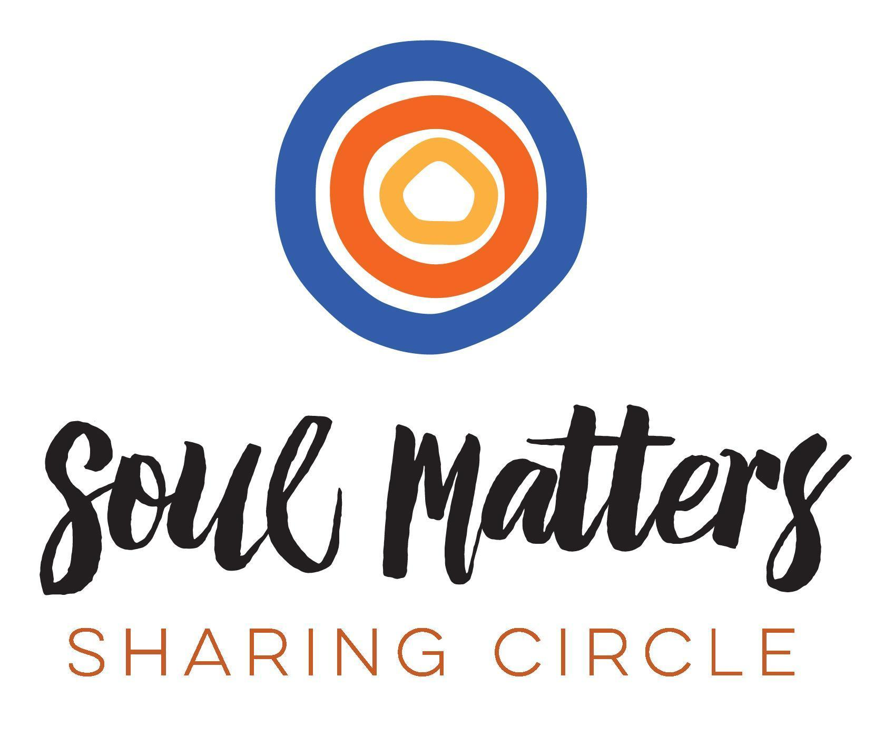

*© 2019-20 Soul Matters ALL RIGHTS RESERVED*

***Packets are for use only by member congregations of the Soul Matters Sharing Circle.***

*Learn how to join at[http://www.soulmatterssharingcircle.com](http://www.soulmatterssharingcircle.com/)*