WRAP® Your Wellness Your Way
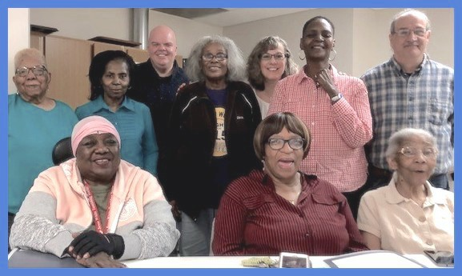
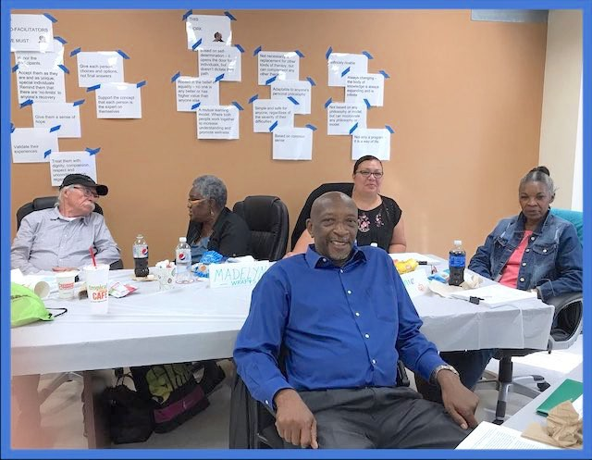
Connecting with Others While at Home

“With WRAP, I'm in charge of my life again.” “Now I have a plan for how to stay well.”
“I don’t feel so alone. I know how to reach out for help when I need it.”
“I feel more of a sense of community with other people now.”

Wellness Recovery Action Plan (WRAP) is a free program anyone can use to feel less isolated and more in control of their life. It is offered online using Zoom.

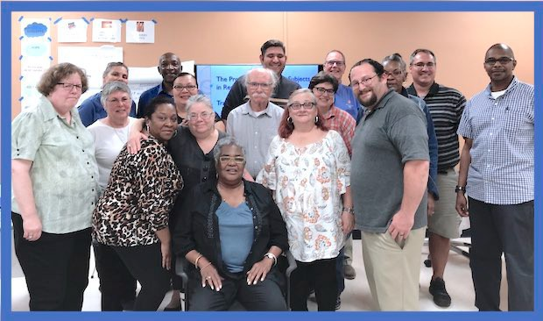

-Discover your own simple & safe wellness tools.
-Develop a simple plan for daily wellness.
-Create simple plans for responding to stress, negative thoughts, & challenging times.
-WRAP supports people in making their own choices for improved well-being, physical health, & quality of life.
-WRAP participants create a personal Wellness Toolbox, while giving & getting peer support.

UIC is offering free WRAP online using Zoom, which requires a smartphone, laptop, or tablet.
UIC will help you download & use Zoom for free.

6 weekly classes for adults (age 60+) start on August 19 through September 23.
This Zoom class is from 5:00 to 6:30 pm
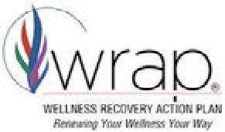
Sign up by typing this into Google (or your internet browser): https://bit.ly/2Zy05ks
The University of Illinois at Chicago is an official Chicago Housing Authority Health Partner
The University of Illinois at Chicago is an official Chicago Housing Authority Health Partner

The University of Illinois at Chicago is an official Chicago Housing Authority Health Partner

The University of Illinois at Chicago is an official Chicago Housing Authority Health Partner

The University of Illinois at Chicago is an official Chicago Housing Authority Health Partner

WRAP® Your Wellness Your Way
Here’s what you'll take away from the class
- You’ll leave with a personalized binder containing your WRAP plan.
- You’ll have new social contacts with people who are also using their plans.
- You’ll learn new things about yourself and how to build on your strengths.
- You’ll receive a framed certificate for completing the WRAP program.

Here’s what you’ll do in the WRAP Program
- Session 1: Meet the WRAP instructors, learn how WRAP works, and recall what you’re like when you’re feeling well. Learn about the 5 Key Concepts of WRAP and how they can support your wellness.
- Session 2: Create a Wellness Toolbox containing your personalized strategies for handling difficult times. You may decide to borrow a wellness tool or 2 from the instructors or other participants!
- Session 3: Create a short list of things to do every day to stay well and see how much better you feel after a week or so. Learn how to manage things that make you feel uncomfortable.
- Session 4: Learn your Early Warning Signs of declining health and your power to act right away to prevent feeling worse. Get tips for how to talk with your doctors to get the health care you want and need!
- Session 5: In case you ever need it, create a plan for emergencies that keeps you in control, even when it seems like things are out of control. Learn how to turn negative thoughts into positive ones. It’s easier than you think!
- Session 6: Create a plan to guide you as you heal from feeling unwell. Get back into action when you feel you’re ready! Learn how to make your WRAP plan work for you by changing it as needed. Now you’ve completed the WRAP Program - great job, let’s celebrate!

The University of Illinois at Chicago is an official Chicago Housing Authority Health Partner
The University of Illinois at Chicago is an official Chicago Housing Authority Health Partner

The University of Illinois at Chicago is an official Chicago Housing Authority Health Partner

The University of Illinois at Chicago is an official Chicago Housing Authority Health Partner

The University of Illinois at Chicago is an official Chicago Housing Authority Health Partner

